37.49: a) 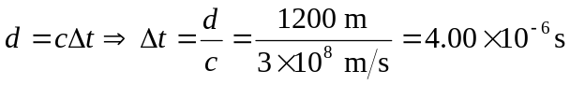 (v is very close to 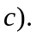
But 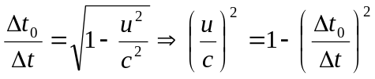
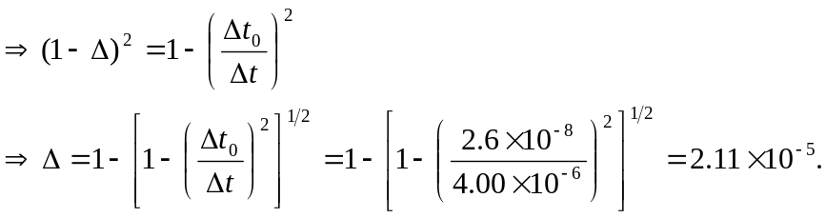
b) 